38.33: 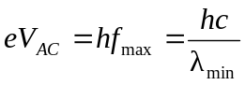
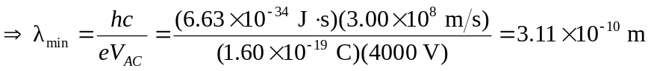
This is the same answer as would be obtained if electrons of this energy were used. Electron beams are much more easily produced and accelerated than proton beams.

